Georg Schlegel GmbH & Co. KG

Red Dot Award for Flexitast
Design and degree of innovation impress independent jury

DÜRMENTINGEN - GEORG SCHLEGEL has once again received the prestigious Red Dot Award. The prize was awarded for the newly developed “Flexitast” display pushbutton. The international jury praised the high design quality and the high degree of innovation of the product.

“The Red Dot Award stands for outstanding design and high functionality. We are more than delighted that our Flexitast has impressed the jury and that we have once again been honoured with this prestigious award,” says Managing Director Christoph Schlegel. The award confirms once again that at SCHLEGEL ”beautiful & good” go together perfectly.

In an evaluation process lasting several days, the independent jury assessed all entries according to criteria such as design quality, functionality and degree of innovation. “The products awarded by the Red Dot jury are united by their outstanding design quality," says a Red Dot press release.

The Flexitast is a true world first: The Flexitast combines a pushbutton with an integrated ZBD display for flexible display of texts and symbols. The centrepiece is a specially developed 72 x 72 pixel ZBD display. Thanks to the technology used, the screen content is retained even without power supply. RGB backlighting with flexible colour selection allows the Flexitast to be adapted to different operating conditions or design requirements.

The Flexitast uses the chip-on-flex technology, where the electronics is placed on the flex cable. This allows for a symmetrical narrow edge and an elegant square display.

The Flexitast can also be used in demanding working environments: A shatterproof glass panel protects the display, and its robust design ensures that the Flexitast remains functional for a long time. Burn-in of the display, which can occur with other technologies, is eliminated.
SCHLEGEL has a long tradition of focusing on design quality. The company, specialising in the development and production of pushbuttons, switches and enclosures for machine control, has already won more than 100 design awards. SCHLEGEL has also won the Red Dot Award for its products in 2018, 2021 and 2023.

Background:
The Red Dot Design Award, whose origins date back to 1955, is considered one of the most coveted seals of quality for good design. A jury of independent designers, design professors and specialist journalists evaluate the entries.

Photo

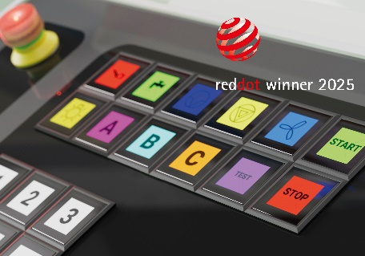
Caption: The Flexitast has been honoured with the Red Dot Award. Photo: Georg Schlegel

Contact details:
Georg Schlegel GmbH & Co. KG
Wolfgang Zoll
Kapellenweg 4
88525 Duermentingen
Phone +49 (7371) 502-0
Fax +49 (7371) 502 49
www.schlegel.biz
vertrieb@schlegel.biz

Media contact:
Georg Schlegel GmbH & Co. KG
Bruno Jungwirth
Kapellenweg 4
88525 Duermentingen
Phone +49 (7371) 502-0
Fax +49 (7371) 502 49
www.schlegel.biz
bruno.jungwirth@schlegel.biz

For publication, free of charge. Specimen copy or indication requested.

About Georg Schlegel GmbH & Co. KG
Schlegel stands for innovation, quality and design. Founded in 1945, Schlegel is today a globally operating company with headquarters in Germany, sales offices in Austria, China, USA and Singapore, and exports to more than 80 countries on all five continents. The core competences: Development and production of control units, pilot lights and terminal blocks. The product portfolio further includes bus systems, enclosures, control panels and functional components. When developing new products, Schlegel sets high standards as to the design. More than 100 national and international design awards confirm the company's high level of design expertise, among these prizes are the iF Design Award, the Red Dot Award, the Good Design Award and the German Design Award.

